ФЕДЕРАЛЬНОЕ АГЕНТСТВО ПО ОБРАЗОВАНИЮ
Государственное образовательное учреждение
Высшего профессионального образования
«Пермский государственный университет»

Кафедра английского языка
профессиональной коммуникации

Английский язык
Australia
Методический материал для формирования лингвострановедческой компетенции студентов неязыковых факультетов

Пермь 2010

Составители: преподаватели Катаева Е.Г., Полякова Н.Е.
Английский язык. Australia: методический материал для формирования лингвострановедческой компетенции студентов неязыковых факультетов. /cост. E.Г. Катаева, Н.Е. Полякова; Перм. гос. ун-т. – Пермь, 2010. 82 с. На англ. яз.

В настоящее пособие включены наиболее интересные и актуальные материалы о жизни Австралии, о ее политической системе, особенностях географического положения, государственного устройства, обычаях и традициях, спортивной жизни и культуре. Тексты снабжены вопросами для проверки понимания.
Методическое пособие адресовано студентам, изучающим английский язык для формирования лингвострановедческой компетенции.

Печатается по постановлению методической комиссии факультета современных иностранных языков и литератур
Пермского университета

©.Катаева Е.Г., Полякова Н.Е., составление, 2010

© Пермский государственный университет, 2010

CONTENT

Geography and climate …………………………………………..4
Australia’s past …………………………………………………. .6
National flag of Australia………………………………………...7
Coat of arms…………………………………………………… .9
Australia’s floral emblem………………………………………..12
Aboriginal Australia……………………………………………..14
Political system ……………………………………………….....17
Australian cities ………………………………………………… 18
Canberra …………………………………………………………19
Sydney……………………………………………………………21
Melbourne ………………………………………………………. 23
Landmarks ……………………………………………………….25
Australian universities……………………………………………29
Flora and fauna …………………………………………………..31
Festivals and events in Australia…………………………………34
Adventure sports in Australia…………………………………….35
Australian traditions…………………………………………… 38
Eating habits ……………………………………………………..44
What are Australians like? …………………………………….....47
Famous Australians …………………………………………… 48
Steve Irwin ……………………………………………………… 48
Ned Kelly ……………………………………………………… 49
Burke and Wills ……………………………………………….....50
Phar Lap ………………………………………………………….51
Banjo Patterson …………………………………………………..51
Ian Thorpe ………………………………………………………..52
Fan facts about Australia ………………………………………...54

GEOGRAPHY AND CLIMATE

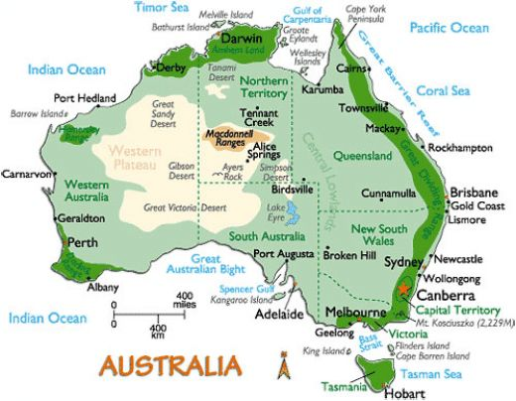

Australia is considered to be the smallest of seven continents and the sixth biggest state. For the reason that it lies in the Southern Hemisphere, its seasons are the contrary of those in the northern part of the world. Australia is situated among the South Pacific Ocean and the Indian Ocean. It is made up of two islands. Australia is extremely close to other island nations. To the north are: Papa New Guinea, Indonesia and part of Malaysia. Additional to the north are the Philippines and Asian mainland. Southeast of Australia is called New Zealand. Like Australia, it was once a British settlement. At last, to the south is the frozen continent of Antarctica.
Nearly half of Australia-the northern part of the county is situated in the earth's hot zone. Australia's tropical area is warm to hot during the whole year. Australia is the most droughty continent on the earth. About one half of its territory is occupied by deserts and semideserts. Most of them lie in the central and north-western part of the country. The Great Victoria Desert is the largest in Australia and the third largest in the world. The inland deserts can remain totally dry for years whilst rains can produce floods.

It is also the land of great plains. Only 6 percent of the island continent is above 2,000 feet (600 metres) in elevation. Its highest peak, Mount Kosciuszko, rises to only 7,310 feet (2,228 metres). Other rock structures in Australia are Uluru, Mount Augustus and Bald Rock.

The main part of Australia lies in tropics.

Australia is a continent that experiences a variety of climates due to its size. The weather can range from below zero temperatures in the Snowy Mountains to intolerable heat in the north-west. It is considered to be one of the driest continents on earth.
The damp season is November through April and the dried out season is May to October. The southern part of the country has a moderate type of weather. It has four separate seasons. Australia’s heaviest rains fall along the north, east and southeast coasts. The damp season brings aggressive rainstorms and cyclones on the north coast and floods farther inner part of the country. Droughts are regular all through much of Australia. Southwestern parts of the country are situated in subtropics. December, January and February are summer months in Australia. The average summer temperature there is from 20 to 30 degrees above zero. Winter comes in June, July and August. Then the average temperature is from 12 to 20 degrees above zero. Droughts are common in Australia.
The rainfall in the country is rather small. The largest rivers in Australia are the Darling and the Murray. In the middle part of Australia there are salt lakes, such as Lake Eyre and Torrence. Most Australian rivers are located near the coast. The largest and longest Australian rivers can be found in the eastern part of the country.

- Why are the seasons in Australia contrary of those in the northern part of the world?
- What is one half of the Australian territory occupied by?
- Can you describe the relief of Australia?
- What type of climate does the country have?
- Are there any rivers in Australia? What are these?

AUSTRALIA’S PAST
Australia has one of the most fascinating and ancient cultural histories on the planet. This isolated continent’s first inhabitants, the aboriginals, arrived on the island around 70,000 years ago and have lived here ever since.
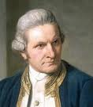
Australia’s modern history, however, begins with the arrival of the Europeans in the 16th century - William Jansz in 1606, and Abel Tasman in 1642, the first Portuguese then Dutch explorers looking for resources to exploit. It was the British, however, who made the greatest lasting impact on this land. In 1770 Captain James Cook sailed along the entire eastern coastline and said Australia now belonged to Britain. Based on his reports, the English decided to colonise Australia, and in 1787 sent the First Fleet to the continent with 11 ships, 750 convicts, soldiers and supplies for two years. They reached Port Jackson - now Sydney-in January 1788. Life was very difficult, and the convicts had to work very hard, making roads, buildings and farms.
In 1851 gold was found in New South Wales and Victoria. Thousands of people went looking for gold - first Australians, then people from North America, Britain, New Zealand and China. In 10 years the population grew from 400,000 to 1,200,000. With the gold came new road and railways and growing cities.
Adding to the original population of convicts, a flurry of free settlers began arriving in Australia over the proceeding decades. When gold was discovered in the 1850s, this distant colony changed forever as a massive influx of prospectors and speculators flooded into Australia, boosting the economy and changing the social dynamics. Aboriginals were forced off their traditional lands to make way for farmers, miners and cattle ranchers. The Industrial Revolution in England was in full swing at this point, and Australia was seen as a major source of materials.
In 1901, Australia officially became a nation when the different colonies joined together in a federation. The Japanese tried to take control of the island during the first part of the 1900s, but with American help they were emphatically defeated. This marked the beginning of the alliance between Australia and the United States which continues today.
After WWII, a wave of European immigrants moved to Australia, revitalising its economy and adding new dimensions to its cultural fabric. The nation is part of the Commonwealth and maintains close ties with the US and Britain.

- Who were the first inhabitants of Australia?
- When does the modern Australian history begin?
- Who is said to discover the country?
- What country had Australia belonged to for many years?
- Why did a lot of people from different countries go to Australia?

NATIONAL FLAG OF AUSTRALIA
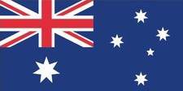
The Australian National Flag is Australia’s foremost national symbol. It was first flown in 1901 and has become an expression of Australian identity and pride. The Australian National Flag flies over the federal and state parliaments. The flag is paraded by Australian defence forces and displayed around the country at sporting events and by service organisations, schools, community groups and private citizens.
The Australian National Flag has three elements on a blue background: the Union Jack, the Commonwealth Star and the Southern Cross. The Union Jack in the upper left corner (or canton) acknowledges the history of British settlement.
Below the Union Jack is a white Commonwealth or Federation star. It has seven points representing the unity of the six states and the territories of the Commonwealth of Australia.
The Southern Cross is shown on the fly of the flag in white. This constellation of five stars can be seen only from the southern hemisphere and is a reminder of Australia’s geography.
The colonies of Australia federated to become a single Commonwealth in 1901. That year, Australia’s first Prime Minister, the Rt Hon Sir Edmund Barton announced an international competition to design a flag for the new nation. It attracted 32,823 entries. Five near-identical entries were awarded equal first and the designers shared the £200 prize. The Australian National Flag was flown for the first time in September 1901 at the Exhibition Building in Melbourne, which was then the seat of the federal government.
It was announced in Commonwealth of Australia Gazette No 8 of 1903 that King Edward VII approved designs for the flag of Australia, known as the Commonwealth blue ensign, and for the flag of the merchant navy, known as the Commonwealth red ensign. The stars of the Southern Cross were simplified to four seven-pointed stars and one five pointed star. (The 1901 design depicted the stars with a differing number of points to signify their brightness.) In 1908 a seventh point was added to the Commonwealth star to represent the Australian territories.
Confusion developed surrounding the use of the two Australian flags. The blue ensign was intended for official and naval purposes only and the red ensign was to be used by the merchant fleet. However, the general public also began using the red ensign on land. In 1941, Prime Minister the Rt Hon Robert Menzies issued a press statement recommending the flying of the blue ensign as a national emblem. The Flags Act 1953 ended confusion about which ensign to use.
An amendment to the Flags Act 1953 was passed in 1998 to ensure that the Australian National Flag can be changed only with the agreement of the Australian people.
Other official Australian flags include the Australian Aboriginal Flag, the Torres Strait Islander Flag and the ensigns of the Australian Defence Force.
The Flags Act 1953 proclaimed the Australian blue ensign as the Australian National Flag and the Australian red ensign as the flag for merchant ships registered in Australia.
The Australian National Flag can be flown every day of the year. As the nation’s foremost symbol, the flag should be used with respect and dignity.
There is also a calendar of occasions for flying the Australian National Flag including Australia Day, ANZAC Day and Australian National Flag Day.

Australian National Flag Day
Australian National Flag Day is an opportunity for individuals, community organisations, local authorities, businesses and schools to celebrate with pride the anniversary of the Australian National Flag. All Australians are encouraged to fly or display the Australian National Flag to celebrate Australian National Flag Day on 3 September each year.
Australian National Flag Day, proclaimed on 28 August 1996 as a national day, celebrates the first time the flag was flown on 3 September 1901. On that day Prime Minister Edmund Barton announced the winners of a competition to find a flag for Australia. It was a large flag, 5.5 metres by 11 metres, and was flown over the dome of the Exhibition Building in Melbourne. At that time the flag was known as the Commonwealth blue ensign; later, the flag became known as the Australian National Flag.

- How many emblems does the Australian national flag have? What does each of them symbolize?
- When was the flag flown for the first time?
- Why do the stars of the Southern Cross have different number of points?
- What confusion concerning Australian national flag can occur?
- When the Australian National Flag Day celebrated?

COAT OF ARMS
The Commonwealth Coat of Arms is the formal symbol of the Commonwealth of Australia that signifies Commonwealth authority and ownership.
The Commonwealth Coat of Arms is used by Australian Government departments and agencies, statutory and non-statutory authorities, the Parliament and Commonwealth courts and tribunals. King Edward VII made the first official grant of a coat of arms to the Commonwealth of Australia in a Royal Warrant dated 7 May 1908. King George V granted the second Commonwealth Coat of Arms in a Royal Warrant dated 19 September 1912.
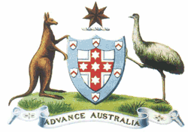
The significant change was to include the symbols of the states on the shield.
The first Commonwealth Coat of Arms
The Arms were composed of a simple shield of white and blue enclosing a cross of St George on which there were five six-pointed white stars, around the outside of which were six small escutcheons, i.e. small shields. The shield was supported by a kangaroo and an emu standing on a grassy mound. Above the shield was the crest containing the seven-pointed gold star of Federation on a wreath of white and blue. The motto 'Advance Australia' was inscribed at the base.

1912 Commonwealth Coat of Arms
The absence of specific references to the states in the shield in the 1908 Arms led to a number of alterations approved on the recommendation of the Commonwealth Government by King George V. The new design included a shield with six parts each containing a representation of the badge of a state. The positions and poses of the supporters were also changed. The colours of the wreath of the crest were altered to gold and blue. These are the 'livery' or identifying colours of the Arms. The new Arms were accompanied by small branches of wattle, ornamental rests for the supporters, and a scroll with the word 'Australia' – none of which are actually mentioned in the 1912 Royal Warrant. There are ten variations of the 1912 Arms – the colour version, four variations of the conventional Arms and five variations of the stylised Arms.
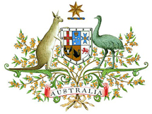
1912 Commonwealth Coat of Arms
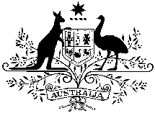
Commonwealth Coat of Arms
(conventional)
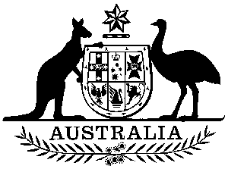
Commonwealth Coat of Arms
(stylised)

Description of the 1912 Commonwealth Coat of Arms
The blazon or official description of the Commonwealth Coat of Arms is contained in the Royal Warrant. The blazon describes a coat of arms in heraldic terms, enabling accurate reproduction in any part of the world. Symbols of Australia’s six states appear together on the shield, which is the central feature of a coat of arms. The border of the shield symbolizes federation.
The kangaroo and emu are the native animals that hold the shield with pride. Some say the kangaroo and emu were chosen to symbolize a nation moving forward. This is based on the common belief that neither animal can move backwards easily.
A gold Commonwealth Star sits above the shield. Six of the star’s points represent the Australian states. The seventh point represents the territories. A wreath of gold and blue sits under the Commonwealth Star. Gold and blue are the Commonwealth Coat of Arms’ livery or identifying colours.
Australia’s floral emblem, the golden wattle, frames the shield and supporters. A scroll contains the word ‘Australia’.

- What is the Commonwealth Coat of Arms?
- Would you describe Australian coat of arms?
- How did the coat of arms change throughout the Australian history?
- Why were kangaroo and emu chosen to hold the shield?
- What represents the Australian states?

AUSTRALIA’S FLORAL EMBLEM
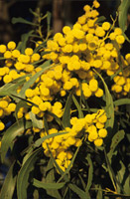
Australia's national floral emblem is the golden wattle (Acacia pycnantha Benth.). When in flower, the golden wattle displays the national colours, green and gold. As one species of a large genus of flora growing across Australia, the golden wattle is a symbol of unity.
Wattle is ideally suited to withstand Australia's droughts, winds and bushfires. The resilience of wattle represents the spirit of the Australian people.
In recent times, the golden wattle has been used as a symbol of remembrance and reflection. On national days of mourning, for example, Australians are invited to wear a sprig of wattle. The golden wattle has been used in the design of Australian stamps and many awards in the Australian honours system. The first day of September is National Wattle Day. It builds on a long unofficial tradition of wearing the wattle blossom on 1 September. The day was introduced in 1913 by an association called the Wattle Day League and formally recognised on 23 June 1992. Australians can celebrate their floral heritage each Wattle Day by planting wattles.
Indigenous peoples of Australia soaked the gum of the golden wattle in water and honey to produce a sweet, toffee-like substance. The tannin from the bark was known for its antiseptic properties. Colonial settlers cultivated the golden wattle using the bark in the tanning industry, the gum for glues and the blossom for its honey. The golden wattle was unofficially accepted as the national floral emblem to mark Federation in 1901.
In 1912 the Prime Minister, the Rt Hon Andrew Fisher MP, suggested that the wattle be included as a decoration surrounding the Commonwealth Coat of Arms. The golden wattle (Acacia pycnantha Benth.) is an evergreen, spreading shrub or small tree. It grows in the under storey of open forest, woodland and in open scrub in South Australia, Victoria, New South Wales and the Australian Capital Territory.
The common name, wattle, is derived from an Anglo-Saxon building technique. Wattles were flexible twigs or small branches interwoven to form the framework of buildings. This style of building was introduced to Australia by early British settlers and species of Acacia were used as wattles. There are more than 760 different types of wattle across Australia.

- What are the national colours of Australia?
- Why was the wattle chosen to represent Australia?
- When do Australians celebrate National Wattle Day?
- How did the first inhabitants of the country use the plant?
- When did the wattle become the symbol of Australia?

ABORIGINAL AUSTRALIA

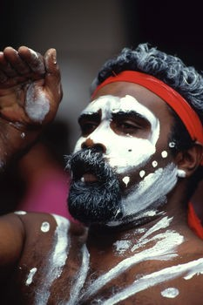
Australian Aborigines or Indigenous Australians are natives of the Australian continent. They migrated to this region from South Asia about 40,000 years ago. Though they comprise 500–600 distinct groups, aboriginal people possess some unifying links. Among these are strong spiritual beliefs; a tribal culture of storytelling and art; and, like other indigenous populations, a difficult colonial history. Aboriginal spirituality entails a close relationship between humans and the land. Aborigines call the beginning of the world the "Dreaming," or "Dreamtime." In the "Dreamtime," aboriginal "Ancestors" rose from below the earth to form various parts of nature including animal species, bodies of water, and the sky. Unlike other religions, however, aboriginal belief does not place the human species apart from or on a higher level than nature. 'Ancestor Spirits' came to Earth in human and other forms and the land, the plants and animals were given their form as we know them today.
All of Australia's Aborigines were hunters and gatherers, with each clan having its own territory. Those communities living along the coast or rivers were expert fishermen. The territories or 'traditional lands' were defined by geographic boundaries such as rivers, lakes and mountains.
Aborigine men usually went to hunt in group. The Australian fauna is original, but poor, and Aborigines had to content from possums to kangaroos and emus. Usually, they did not hunt dangerous animals, except the crocodile. The hunter knew by the traces the species and the age of the trace. Aborigines looked for filtering how much they could close to the large prey (like kangaroos) to a distance that allowed them to kill with the spear. Sometimes the hunters smeared their body with clay for camouflaging during the hunt. The most curious weapon was the boomerang, used for hunting rapid animals and birds, while for hunting emu or bush turkeys was employed the spear. The boomerang has the property to return to its launcher if missing the target. In the Aborigine group, children received special care, receiving the best food, a lot of affection and not being punished for their pranks. Children stayed with the women, helping them in gathering berries, seeds and small animals (insects included).
When the boy reached 10-12 years of age, he would pass through a series of ceremonies: his body was tattooed and painted and he was taught legends and customs of the tribe, he learnt to hunt, and he was submitted to a series of physical probes meant to fortify him. This learning period could last years, and when considered adult, he could marry.
The Australian Aborigines possess culture and heritage and a history distinct from other groups around the world. The native language of the Australian Aborigines is not known to be related to any of the languages in other parts of the world. Today, there are fewer than 200 indigenous Australian languages that are in use.
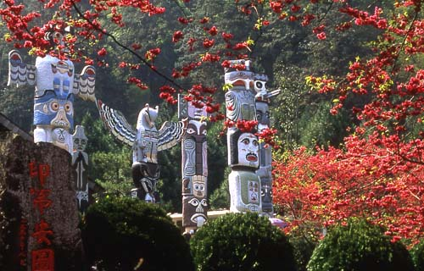
Australia’s culture is rich with the tradition of Aboriginal art. The art forms date back to more than thousands of years. The rock art and bark painting display the Australian Aborigines in harmony with nature. This relationship between the people and their environment is most visible in the use of earthly colors in the paintings, most of which are made from ochre. Things have changed and today the modern Aboriginal artists continue the tradition, but with the use of the versatile modern materials.
The most important festivity of the Aborigines is the corroborri. The men adorn themselves with feather headdresses, imitating the look of the totem animal of the tribe. The magic ceremony has as a final purpose the achievement of the favor of the spirits of the animals which the Aborigines wanted to hunt so that they came in the reach of their weapons. By mimicking animals' movements, Aborigines took over the spirits of the animals forcing them to accomplish their will.
The corroborri dance is accompanied by the singing and the rhythmic beating of wood pieces: the rhythm and velocity grew gradually till the dancers fell exhausted to the ground.
Aboriginal music is often recognizable for its most famous instrument, the didgeridoo. A wind instrument typically made from bamboo, it extends about five feet and produces a low, vibrating hum. Aborigines use didgeridoos in formal ceremonies at such events as sunsets, circumcisions, and funerals.
Today, most Aborigines have adapted to the western lifestyle, working mostly as herders in the inner grassland areas of Australia. The health and economic difficulties are substantial, with adverse ratings on the social indicators like education, unemployment and poverty.

- When did the aboriginals settle the Australian continent?
- What is “Dreamtime”?
- How did the aboriginals get food?
- What did the aboriginals use to kill animals?
- How were the aboriginal boys brought up?
- What can you say about the aboriginal culture?
- What is the most important festivity of the aborigines? How is it celebrated?
- What is aboriginal music recognizable for?
- How do the most aborigines live today?

POLITICAL SYSTEM
The Commonwealth of Australia is a constitutional monarchy with a parliamentary system of government. Queen Elizabeth II is the Queen of Australia, a role that is distinct from her position as Elizabeth II of the United Kingdom. The queen is represented by the Governor General, who is appointed by the Australian government. The Governor General appoints members of the Executive Council, his advisory cabinet. The main legislative body in the country is Federal Parliament. It consists of the Queen, the Senate and the House of Representatives. The members of the Senate are elected for a six-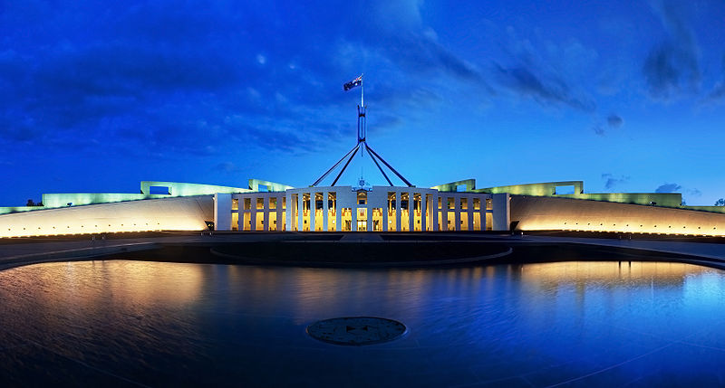year term. There are ten senators from each state and two from each territory in the Senate. The House of Representatives is elected by general direct vote for a three-year term. The executive power belongs to the queen and the government. It is headed by the Prime Minister. The ministers are chosen from members of Parliament and the Executive Council. There are three major political parties: the Labor Party, the Liberal Party and the National Party.
Australia consists of six states joined together in 1901 and two major mainland territories. The states are New South Wales, Queensland, South Australia, Tasmania, Victoria and Western Australia. The two major mainland territories are the Northern Territory and the Australian Capital Territory.
The Australian system of government reflects the influence of both the British and American models with some uniquely Australian characteristics, especially in its electoral system.
It is the only English-speaking country in the world that has made voting compulsory in federal and state elections. Australian citizens eligible to vote are required to do so and risk being fined if they do not vote. Another interesting feature of Australian electoral practice is the use of "preferential voting" for most elections. In this system voters number the candidates in the order of their preference or allow the political party of their choice to allocate their vote according to a pre-determined order of preference.

- What is the political name of the country?
- Who is the head of the state?
- What is the legislative branch of power represented by?
- Who does the executive power belong to?
- What does Australia consist of?
- What is special about voting in Australia?

AUSTRALIAN CITIES
Australia is one of the most urbanized countries on earth, with up to 85 percent of the population living in cities. Yet, Australia is also one of the world’s most sparsely populated countries. The country's total population is around 22 million people, who inhabit a country with a land area bigger than Europe or comparable to mainland USA.
Most metropolitan centres and towns in Australia were constructed in the 19th and 20th century so they are modern and resemble North American rather than European settlements, although they have their own influences.
The trend towards urbanisation is stronger in Australia than many other parts of the world due to much of the landscape in Australia being harsh and unable to support large populations. Sydney is the most populous city in Australia and is built on what many people say is the most beautiful harbour in the world. Sydney's main landmarks, the Opera House and the Sydney Harbour Bridge are iconic of not just Sydney but of Australia too. Australia's second biggest city, Melbourne is the most European of all Australian cities with sizeable immigration from Italy and Greece, the city is the fashion and food capital of Australia. Brisbane the third biggest city enjoys a sub-tropical climate and is a city built around a river with spectacular beaches to the north and south of the city. Both Perth, and Adelaide have a mediterranean climate and populations between 1 and 2 million people.
The Gold Coast is a coastal city just south of Brisbane. It is famous for it's beaches and coastal high-rise developments.

- What is the population of Australia?
- What are most metropolitan cities and towns in Australia like?
- Why is the trend to urbanization in Australia so strong?
- What are the biggest Australian cities?

CANBERRA
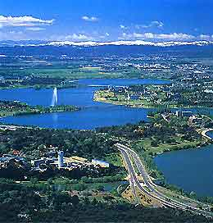
Canberra is the capital of Australia and is located 150km inland from the southeast Australian coast. Small and modern, it is cocooned within its own small territory, the ACT. Canberra is a planned city and was constructed originally as the capital to solve the rivalry between Sydney and Melbourne for the title. As a result it’s easily accessible layout is perfect for those who want to see the inner city on foot.
There is plenty to see and do in Australia’s capital – from enlightening historical and political locations, to the beauty of the great outdoors – Canberra has something for everybody.
Before going anywhere, it's a good idea to call into the National Capital Exhibition. This gives a good introduction to the city. Look for the Captain Cook Memorial jets which blast tonnes of water from the lake skywards and nearby Regatta Point outlining Cook's voyages. The National Gallery of Australia houses the national art collection and hosts exhibitions from around the world. With over 100,000 impressive pieces of priceless art it's one of Australia's most highly regarded tourist attractions. It's easy to spend a day wandering through this excellent gallery - definitely a must see.
No Canberra itinerary would be complete without the unique city symbol, Parliament House. Visitors to Parliament House are welcome on non-sitting days with regular free tours taking groups through The House of Representatives, the Senate gallery and various rotating exhibitions held throughout the year - short tours are still conducted on sitting days for those who wish to see the proceedings. Nearby the Australian War Memorial has an impressive collection of memorabilia and war records, as well as regular exhibitions that commemorate the sacrifice of Australians who have died in world conflict. Each year, hundreds of visitors come to pay their respects at the memorial on Anzac Day and Remembrance Day, and smaller ceremonies are held each week at the Tomb of the Unknown Soldier.
The countryside surrounding Canberra has many outdoor delights. Black Mountain, Mount Ainslie, Mount Taylor, Mount Pleasant, Red Hill and Mount Majura are all within easy reach of the city, and are good places to spot different species of native Australian flora and fauna. In the Tidbinbilla Nature Reserve, the Nature Discovery Sanctuary allows visitors to see the wildlife in its most untainted state – with no cages or fences.
Canberra is known as Australia's bush capital due to the large amount of natural vegetation in and around the city, which flourishes in Canberra weather.
One of Canberra's main natural attractions is the Floriade festival, Australia's biggest flower festival, a colourful celebration of flowers held each spring.
Although Canberra is small it is culturally diverse. But still, the capital has a reputation for being boring and lacking soul. That may be a little unfair but it is undeniable that few go to Canberra for a holiday. Canberra is however unique, and makes a good stopover en route to Melbourne, Sydney or the Snowy Mountains.

- What is the Australian capital territory's name?
- What can you see in Canberra?
- What is the main attraction of the city?
- Why is Canberra known as Australia's bush capital?
- Is Canberra a popular place for holidays?

SYDNEY
Sydney was founded by English colonists 200 years ago and was first populated by convicts. It is one of the most beautiful modern cities in the world and offers a unique experience to all its visitors. It is located on the east coast of Australia and is famous for its wide range of tourist attractions and fun things to do.
These include visiting The Rocks, the area of Sydney where the colony was first begun with a few sly grog shops for the sailors and soldiers. It was chosen because it had a natural spring of water for drinking. (This water still runs underneath the modern city and it's called the Tank Stream.)
The Rocks area stands right underneath the Sydney Harbor Bridge and is full of old buildings and pubs (bars / taverns) which date back 150 years or more. It is a natural highlight of any tour of Sydney.
Sydney Opera House is one of the most visited and pictured sights in Australia. Being one of the World wonders with canoes and small ships around it, the Opera House is the pride of the city. 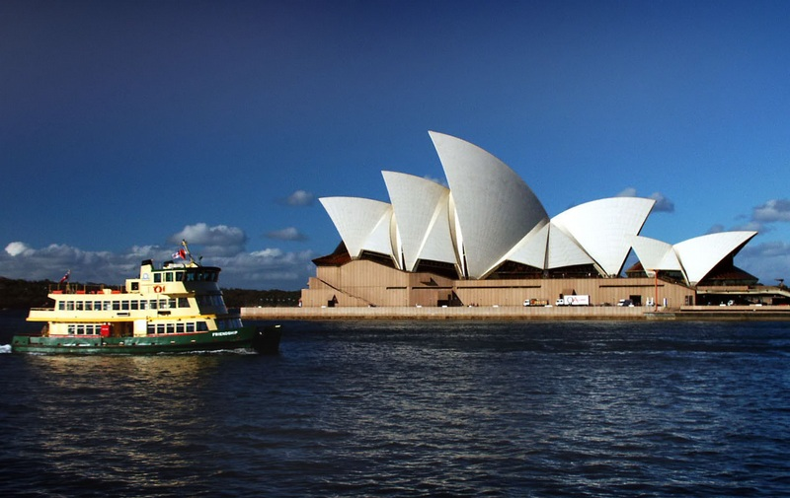
Most of the Australians' national entertainment is cruising, water tours and diving and each occasion (either wedding or other outstanding agendas) is followed by visiting or sailing around awesomely built in the form of the huge ship sales Opera House surroundings. Of course there are other interesting buildings and monuments there.
Sydney is a very big city but the main attractions are located in a small area which is also one of the most luxurious areas in the city. The beaches in Sydney are simply amazing, that's why they are crowded of people in summer time, there are more than 20 waiting for you, the most famous between them is Bondi, located seven kilometers away from the city centre, is very visited in summer and through all the year, many tourists come here to spend Christmas time.
Manly Beach is also a very visited tourist destination, it's near the Sydney Harbour National Park, you can take the ferry to get there in thirty minutes or can take the fast Jet Cat catamaran to be there in fifteen minutes. And to come back from a fantastic day on the beach the best time to get into the city is at night, the lights of all the city gives to it a special view, you have to see the lights of the tallest buildings around Circular Quay looks like rainbows over the water of the harbor.
Sydney population is of about five million people, you'll discover this city still has a small-town charm.
In 2000 Sydney was the host city of the Olympic Games, all the city was full of visitors, journalists and sportsmen, there was a beautiful time in the city because of this.
Sydney is also the dynamic centre for Australian economic activity and one of the most important cities for finance in the Asia-Pacific region.

- Who were the first residents of Sydney?
- What is the Rocks?
- What attraction is the pride of the city?
- Are there any beaches in Sydney?
- What is the population of the city?

MELBOURNE

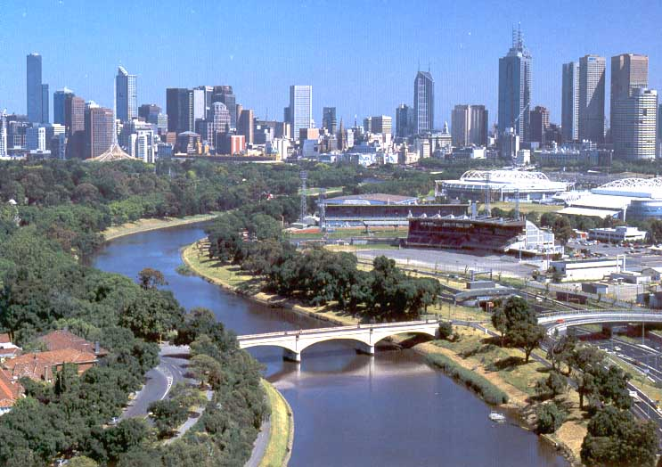
Melbourne is the second largest city in Australia, and is the capital city of Victoria region, always in competition with Sydney in different areas such as sport and economy. Melbourne is located near the Yarra River and sometime was the main city in Australia. Is called the Marvelous Melbourne for its unique environment, it has it all, modern buildings, beautiful beaches and can be said is the most cultural city in the country, gives a lot of importance to the sports and here is realized the famous Australian Tennis Open, the Melbourne Cup and the Australian Grand Prix.
Melbourne can be considered one of the world's largest cities in area having approximately 6110 sq.km. It has many gardens and parks which occupy the third part of this area.
The city was founded in 1835 by John Batman, and its name is in honor of Viscount Melbourne, William Lamb, during the British occupation of Victoria. Since then Melbourne began to grow as a city and commercial centre on the north end of Port Phillip. The first magistrate in this city was Captain William Lonsdale, who came from Sydney to establish the order and law.
In 1847 Melbourne was declared as a city by Queen Victoria, and in 1850 with the gold discovery the city turned into the major port of Victoria region, the Melbourne's hustle and bustle was incredible then, with ships from all over the world arriving here, in 1854 the population increased in almost four times its number and the city development was obvious and more industries services were implanted, with all of this Melbourne became the main financial centre in all Australia.
Because of the gold rushes Melbourne received many migrants from many parts of the world, specially from Italy, Greece, Poland, Turkey, Yugoslavia and Vietnam, all of this contributed to make of Melbourne a very special and varied city, with traditions of many different ways, and this mixture can also be seen in the restaurants, architecture and festivals. There is China Town , the Greek precinct, the Italian quarter, and more – each of them with their distinctive shopping and dining experiences from around the world. If you are on a history trail, there is a fantastic array of historical Melbourne attractions . Throughout the city there are many heritage buildings as well as stunning new constructions along its wide tree-lined avenues and in its intimate lanes. For a deeper understanding of Melbourne’s history, there is a whole list of museums Melbourne is proud of: the Gold Treasury, the Melbourne City museum, the Immigration museum, and the Old Melbourne Goal are just the beginning of a list of places tracing Melbourne’s past times and influences.
Right on the Yarra, there is the Melbourne Aquarium , Australia’s only Southern Ocean aquarium. The state of the art complex, featuring over 1000 sea creatures, including giant sharks and stingrays, is well worth a visit.
There is a long list of Melbourne tourist attractions. Many visitors return to Melbourne to take in elements missed on earlier visits - and even locals are still finding new areas to explore.

- Where is Melbourne located?
- Why is it often named Marvelous Melbourne?
- How did Melbourne get its name?
- How did the discovery of gold change the city?
- What can you see in Melbourne?

LANDMARKS

Australia has numerous landmarks located all across the country, covering all states and territories, these include both man made (e.g. The Opera House in Sydney, New South Wales) and naturally occurring landmarks (e.g. Uluru in the Northern Territory).
The Sydney Opera House is probably Australia’s most instantly recognizable landmark. With its soaring, sail-like arches that dominate its unique construction, the Sydney Opera House has come to represent Australia just as the Eiffel Tower represents France or the Roman Colosseum represents Italy. Queen Elizabeth II opened the structure to the public on October 20, 1973 and since that time the Opera House has become the busiest public venue in the world with some 3000 performances each year and a yearly audience of over 2 million. Guided tours are available, and over 200,000 people a year visit the architectural marvel each year just to tour it.

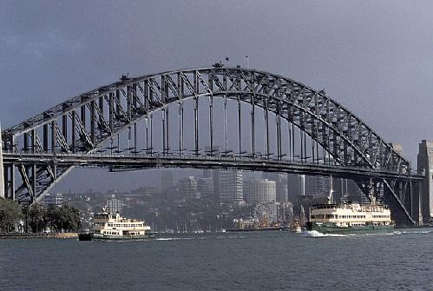
The Sydney Harbor Bridge, affectionately known locally as “The Coathanger”, is the world’s most massive steel arch bridge with the highest point soaring 134 meters above the harbor below. The bridge opened in 1932 and stands as an architectural marvel to this day. Images of the bridge are instantly recognizable around the world. Visitors to the area can take advantage of the Bridge Climb where, for a fee, they are escorted into the network of catwalks to the top of the span in the center. From here, the most spectacular view of Sydney Harbor can be experienced. The Bridge Climb can be taken during the day, twilight, or night for different panoramic perspectives.
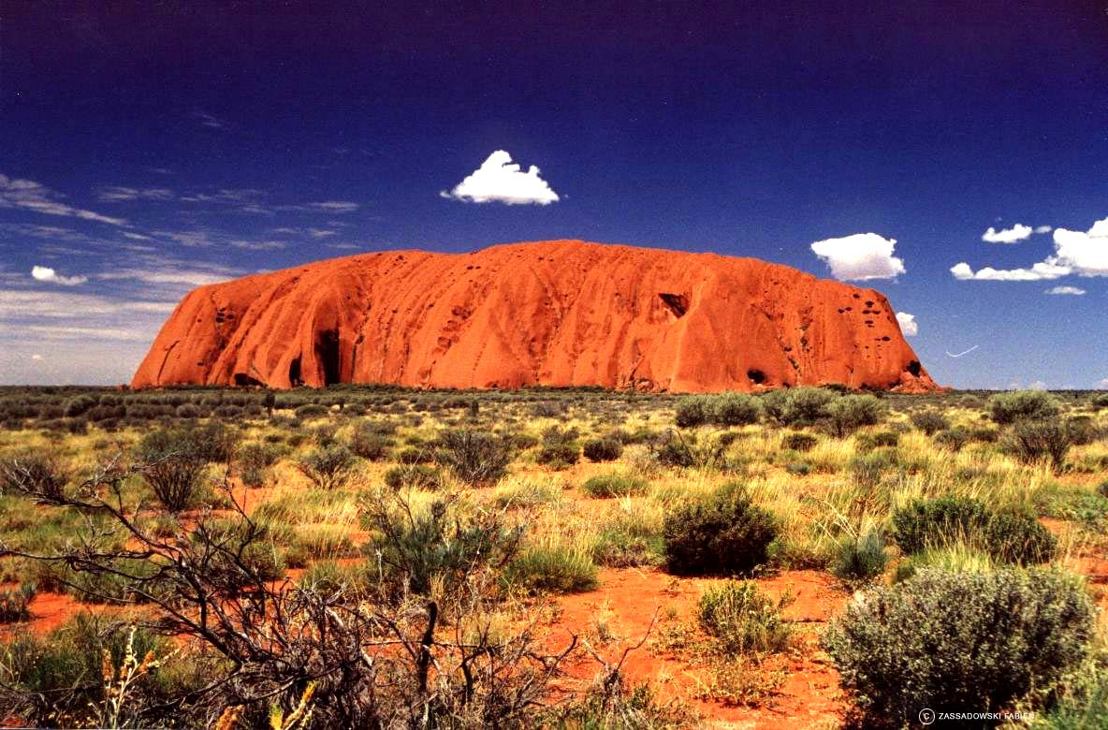
Uluru, formerly known as Ayers Rock, is the world’s largest monolith, or single piece of stone, on the planet. Uluru is the traditional name given to the monolith by the local Pitjantjatjara [ Pitjantjatjara] people of the region who greatly revere the structure and attach significant spiritual importance to it. Uluru stands in stark contrast to the desert scrub surrounding the huge sandstone formation. Much like an iceberg in the cold seas, much of Uluru’s mass is hidden underground, but above ground Uluru soars 348 meters high and has an elliptical shape with a circumference of 9.4 kilometers. Guided walking tours are available of this geological marvel and Uluru is particularly notable for its striking appearance at different times of the year as it appears to change colors with the different light angles.

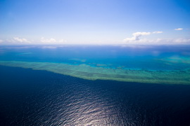
Great Barrier Reef
The whole continent of Australia is a land of unique natural wonders, but the Great Barrier Reef is the most famous. The Great Barrier Reef is, by far, the world’s largest coral reef system stretching 2600 kilometers in the aptly named Coral Sea off the coast of Queensland. With an area of over 300,000 square kilometers, the huge reef system can make the sole claim that it is the only visible living structure from outer space. The Reef is truly a natural wonder populated with unusual wildlife like the dugong, Loggerhead sea turtle, and many species of dolphins.


Port Arthur is a great tourist destination full of Australian history. Founded as a penal settlement in 1830, Port Arthur originally served the British Empire as a timber station. Industry in the area soon followed and by the 1840s Port Arthur had a convict population of over 1100. However, by the 1870s the convicts were gone and left the buildings of the period that stand to this day that weren’t destroyed by fires in the late 19th century. Today, ongoing archeological studies continue to dig up the penal colony past.

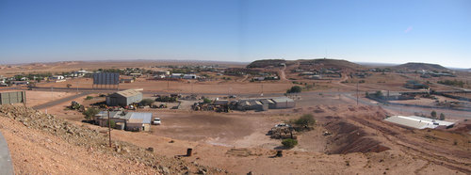
Coober Pedy is most famous for the unusual lifestyle of a significant portion of it local residents who live underground all year. This practice came about when local resident sought escape from the oppressive heat before the days of modern air conditioning. Also known as the “Opal Capital of the World”, Coober Pedy was first established as an opal mine in 1915. Today tourists can visit the old opal mines, visit underground churches, and lodge underground in a motel. 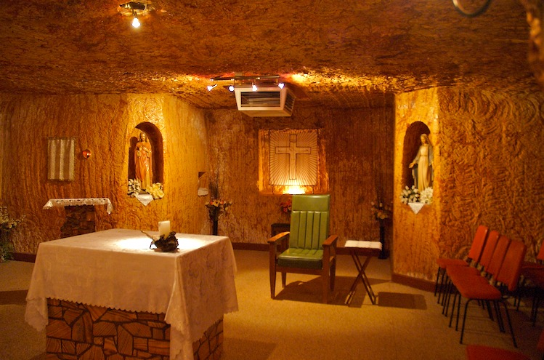

The local golf course, with no grass, is played at night with glowing golf balls and a portable divot to tee from. The area is also devoid of trees and served as the backdrop for the post-nuclear apocalypse film titled Mad Max Beyond Thunderdome starring Australian son Mel Gibson. Find a Coober Pedy hotel and enjoy this must see landmark in Australia.

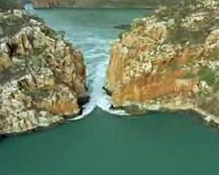
The Horizontal Falls
The Horizontal Falls, near Talbot Bay, in the north-west of Western Australia is described as "one of the greatest natural wonders of the world". Although they are called waterfalls, this natural phenomenon actually consists of immense tidal currents hurtling through narrow coastal gorges. And they do all this sideways - hence the name, Horizontal Falls.
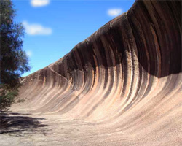
Wave Rock
Wave Rock is a natural large stone formation in Western Australia near the town of Hyden. The formation is said to be many millions of years old and contains strips of grey and red granite in the wave formation. Its rounded wave-like shape, formed by weathering and water erosion, reaches 15 metres in height and extends 110 metres in length. Nearby there are other rock formations such as the Hippo's yawn, The Falls and the Breakers.

- Which of the landmarks is considered to represent the country?
- What is special about the Sydney Harbour Bridge?
- Can you describe the world's largest monolith?
- What is the most famous natural wonder located in Australia?
- Where can you learn a lot about Australian history?
- Why do the residents of Coober Peddy live underground all year round?
- Why did the Horizontal Falls get such a name?
- What is Wave Rock formed of?

AUSTRALIAN UNIVERSITIES
Australia is the third most popular study destination in the English-speaking world. With more than 200,000 international students in Australian institutions across all education sectors: higher education, vocational education and training, English Language colleges, and schools. Its universities have a proud tradition of teaching international university students and impressive record of excellence. They exchange staff with institutions overseas, participate in international forums, and have partnerships and joint projects with overseas institutions and international research centers.
There are 39 universities in Australia, two of which are private. The Australian higher education sector offers a complete range of programs leading to highly regarded and internationally recognized qualifications. A number of other institutions are accredited to offer degree courses in particular fields, such as theology, dramatic arts, radio, television, maritime studies and management. University studies can be undertaken at the undergraduate or postgraduate level, leading to awards ranging from graduate certificate to doctorate.

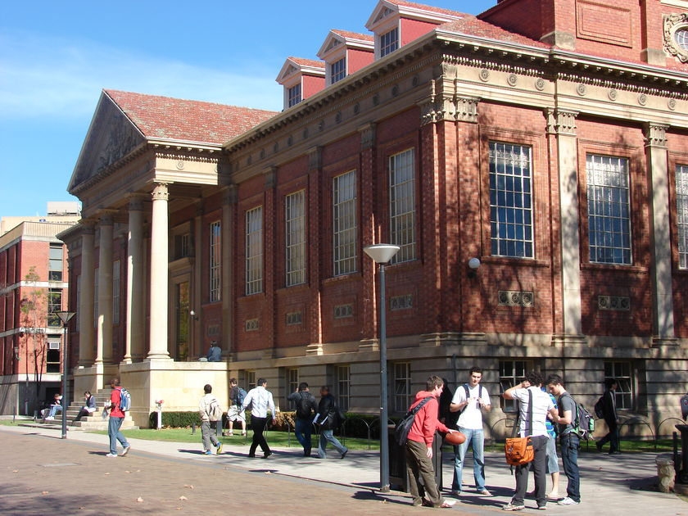

The publicly funded universities in Australia belong to a national system of universities, of which diversity and autonomy are central features. Each institution has the freedom to specify its own mission and purpose, modes of teaching and research, constitution of the student body and the range of the educational programs. Such freedom is also evident in the two private universities which function outside the public system. There are universities in all major Australian cities and throughout regional areas of the country. The University of Adelaide is one of Australia's oldest and one of the highest ranking universities in Australia. Established in 1874, it is a member of the 'Group of Eight'. There are more than 1,800 international students among the 14,000-strong student population. An innovative and forward-looking University, Adelaide has major strengths in health sciences, biological sciences, physical sciences, information technology and telecommunications, environmental sciences and social sciences. Higher education in Australia has been divided into a semester pattern. Universities have two semesters a year that are normally between February and November. There are several universities in the country that have an optional short summer semester. A semester is scheduled with lecturers, tutorials, practicals, and seminars. Typical course subjects you will be studying include: foreign language (usually French or Asian languages), math, English, science and physical education. Campus creates a lively and dynamic environment in which to study. Student life can encompass areas such as health and wellness, career, campus involvement, fitness, entertainment, clubs, getting around your new city, and other support services. It also covers basics from parking fees, buying textbooks, getting a student card and other campus neccessities. Students can use their free time to travel or in employment. Learning and studying in Australia is the perfect way to launch your career. Employment opportunities open up to those who have degrees from any one of the universities, whether they study in Sydney, Melbourne, Brisbane, Perth, Adelaide, or at any of the other higher-education institutions located around Australia

  - Are most Australian universities public or private?
  - What does the Australian higher education sector offer?
  - What are central features of Australian universities?
  - What does a typical course of subjects include?
  - What support services are Australian students offered?

FLORA AND FAUNA
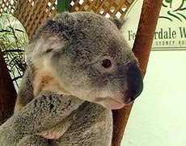
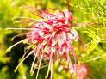
Australia is a land like no other, with about one million different native species. More than 80 per cent of the country’s flowering plants, mammals, reptiles and frogs are unique to Australia, along with most of its freshwater fish and almost half of its birds. Australia’s marine environment is home to 4000 fish species, 1700 coral species, 50 types of marine mammals and a wide range of seabirds. Most marine species found in southern Australian waters occur nowhere else. Australia’s geographic isolation has meant that much of its flora and fauna is very different from species in other parts of the world. Most are found nowhere else. However, some closely related species are found on the continents which once made up the ancient southern supercontinent Gondwana. Covered in rainforest and ferns 300 million years ago, Gondwana included South America, Africa, India and Antarctica. Most of Australia’s flora and fauna have their origins in Gondwana, which broke up about 140 million years ago.The most common tree in Australia is the Eucalypt, of which there are about 500 different species. Eucalyptus trees are found in almost all regions of Australia, and have become known as the iconic 'Aussie tree'. Another family well known are the Acacia and Wattle species - the Golden Wattle is Australia's national floral emblem.
The desert regions feature beautiful, hardy flowering plants like the Kangaroo Paw and the Sturt's Desert Pea. Because of the unique bird and insect species, flowers have devleoped unique appearances designed to attract particular creatures - such as the Grevillea and Hakea.
Species such as the Banksia, with hard, woody flower pods, are designed especially to germinate after bush fires - the flames burn the pod and release the seeds into the rich, post-fire soil where they successfully grow in the new generation bush-land.
Australia is blessed with a fascinating mix of native fauna. In Australia there are more than 378 species of mammals, 828 species of birds, 300 species of lizards, 140 species of snakes and two species of crocodiles. Among Australia’s best-known animals are the kangaroo, koala, echidna, dingo, platypus and the Tasmanian Devil, which is now found only in Tasmania.The Koala is one of those animals that have done as much as anyone to promote Australia. There are two species of these cuddly little creatures, the Southern Koala and the Northern Koala.The Koala eats eucalyptus leaves and spends most of his day sleeping. The have soft grey fur and don’t do a great deal other than eat and sleep.
The Kangaroo is an Australian icon and you can find one on the Australian coast of arms. There are four different types of Kangaroos. They are the Red Kangaroo, the Antilopine Kangaroo, and the Eastern and Western Grey Kangaroo.The Kangaroo has had his name since first being seen by Captain James Cook in 1770. The kangaroo and koala have got the pouch in which they carry their cubs.
Other native Australian animals include the Echidna named after a monster in ancient Greek mythology. These small mammals are covered with coarse hair and spines. The echidna is one of only two mammals that lay eggs, the other being the Platypus. The arrival of people (Aborigines) to Australia, a bridge from Asia and European settlers in 1788, had a significant impact on the Australian fauna. Europeans introduced alien species, often competing with native. Agricultural development has caused the destruction of the original background which led to the extinction of many species. Now protects the original ecosystems and native species through protective legislation and the establishment of National Parks.

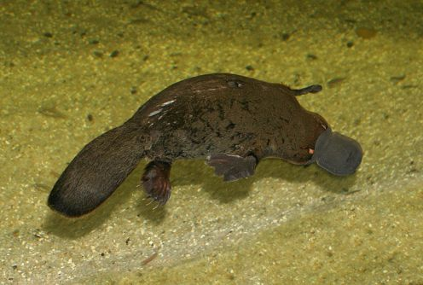
    - What is special about natural world of Australia?
    - What is the iconic 'Aussie tree'?
    - How did Australian plants adopt to the climate?
    - Could you name some species that live only on the Australian continent?
    - How did the kangaroo get its name?

FESTIVALS AND EVENTS IN AUSTRALIA

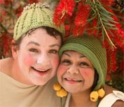
Australia is a proud land of a rich cultural background. It is one of the best places on earth to be visited, thanks to countless Australia Tourist Attractions. Whenever you plan to visit Australia, you will find some festival or other. But in case you want to be a part of specific festivals in Australia, it is a good idea to plan your trip accordingly. The festivals in Australia differ not only in terms of their basic themes, but also in terms of scale of organization, resources, participation and spread in terms of geography. Some are as small as the community-based Apollo Bay Music Festival and Thirroul Seaside & Arts Festival, while others afford the opportunity to bring international performers to Australian audiences and show Australian works, such as the Falls Festival and Woodford Folk Festival.
The Perth International Arts Festival is the oldest annual international multi-arts festival in the southern hemisphere and is Western Australia's premier cultural event. The first Perth Festival was in 1953 and it now offers the people of Western Australia some of the best international and contemporary drama, theatre, music, film, visual arts, street arts, literature, comedy and free community events. Some other events on the program include the Contemporary Culture program and the Perth Visual Arts Festival. As well as these, there are other satellite festivals surrounding the main festival which itself offers more than 30 Australian premieres. Part of the Perth International Arts Festival (PIAF), the Western Australian Indigenous Arts Showcase (WAIAS) involves over 90 Indigenous singers and songwriters, musicians, actors and comedians from all over Australia's largest state.
Sydney Festival is another festival, that offers a rich and diverse program spanning all art forms including dance, theatre, music, visual arts, film, forums and large scale free outdoor events. It stretches for almost three weeks in the month of January.
Another famous festival is none other than the National Multicultural Festival, of Canberra. It is held over two weeks in February and features the very best in local, national and international music, dance, food and creative arts.
Some of the other famous festivals and events in Australia are Ten Days on the Island, Tasmania, Adelaide Bank Festival of Arts, National Folk Festival, Canberra Brisbane Festival, Darwin Festival, and plenty more. Entertainment is just at its best with the success of these events. You can never run short of festivals and events in Australia, as there are many in the offering. Most of them offer a true glimpse into the intriguing cultural heritage of Australia. More importantly, they reflect the passion of people into fine art, dances, ethnic crafts, music and decorative art, among others. And witnessing these festivals and events, you are sure to get to know more about the country and its culture.
While these festivals are an occasion to celebrate differences and art, for the people in Australia most offer the perfect way of spending quality time with family and friends.

        - How do the festivals in Australia differ?
        - What is the oldest art festival? When and where is it held?
        - At what festival ingenious culture is represented?
        - What event takes place in February?
        - Can you name some other famous Australian festivals?

ADVENTURE SPORTS IN AUSTRALIA

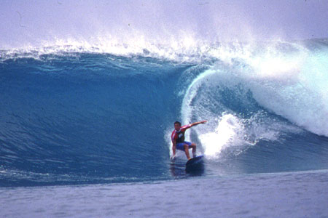

Australia is a land of adventure. This is one of the countries which has always attracted people from all over the world because of the different types of adventure sports available here. The adventure sports in Australia are also known to attract not only children and youth but also the aged people as well. There are different types of adventure sports in Australia. It is said that Australia is a haven for different types of outdoor activities. The pleasant weather also makes outdoor activities extremely popular in Australia. Some of the popular adventure sports in Australia are given below. Have a look to know more:
Bungy Jumping: This is one of the most popular adventure sports in Australia. This is one of the sports especially played in the Cairns region in the Tropical North Queensland. The main site for bungy jumping is Smithfield. This is a place located with the rain forest. The jumpers have an option of plunging into a pool. You will also have the AJ Hackett Bungy Tower. But it is advised that people with heart problems should not try this. There is an elastic rope which is a savior.
Skydiving: This is also one of the top adventure sports in Australia. This is one of the sports in which a large number of people participate. Sydney in New South Wales is one of the top sites for skydiving. There are two companies here which will help you in Skydiving. They are Sydney Skydivers and Simply Skydive. You can go up to 14000 feet high up and have an exotic look of the city as well as the Blue mountains. You can also get photographs as well as DVD of the umps as well.
Canoing: This is also one of the popular adventure sports in Australia. The best spot for this adventure sport is said to be the Blue Mountains near the New South Wales. This is also said to be one of the World Heritage Sites as well. This is also very near to Sydney. There are various cannoning trips available here as well. Through this trip you will be able to visit the Wollemi Wilderness Area.
White Water Rafting: This is also one of the top adventure sports in Australia. The main spot for white water fating in Australia is known to be the Franklin River. This is located in Tasmania. This is one of the fast flowing rivers which has a large number of rapids as well as unnerving drops as well. It is a challenge for a large number of white water rafters as it is a grade five territory. You can also find the Derwent and Picton rivers which also offers the white water river rafting facilities in Australia.
Scuba Diving: This is also one of the top adventure sports in Australia which is popular among a large number of people all over the world. This is one of the sports which is available in different beaches of Australia.
There are sport happenings and holidays in Australia year round. Here are some of them.
In February there's Regatta Day with boat races and other water activities.
In June in Darwin the Beer Can Regatta takes place when there are boat races for boats constructed entirely out of beer cans — there are plenty of those in the world's beer drinking capital.
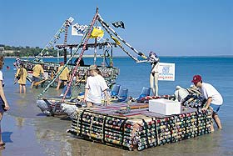
In August in the Northern Territory camel racing is on in Alice Springs, arid then the Apex Rodeo is held, one of the biggest rodeo in Australia — the town fills up with cowboys.
Meanwhile in Sydney, Australians biggest race takes place with 25,000 competitors running the 14 km from Hyde Park to Bondi Beach in the city ace. It is a public holiday in Victoria but the whole country shuts down for the three minutes or so which the race takes.
In December the Sydney-Hobart Yacht Race starts on the 26th, a fantastic sight as the yachts stream out of the harbour and head south.
- Why are adventure sports so popular in Australia?
- What are the most popular adventure sports in the country?
- Why is the Franklin River the best place for white water rafting?
- Can you name some sport happenings and holidays in Australia?
- What is special about the contest taking place in Darwin?

AUSTRALIAN TRADITIONS
Australia Day
Australia doesn't have many traditions. Attempts to get Halloween off the ground have stalled due to one too many homeowners telling little kids to get off their property or they will see a scary sight.
Australia's equivalent of America's Thanksgiving Day is Australia Day on January 26, the landing of the First Fleet of Convicts in Botany Bay. Unfortunately, there is much more emotional resonance in celebrating pioneering pilgrims who broke bread with the natives than there is in celebrating criminals that stole bread and were duly hung. Needless to say, Australia has no tradition of putting the old ball and chain on your leg, and subsequently walking down the street in tribute to the founding fathers. Likewise, Australia has no statues of the pioneering Convicts holding up their shackled wrists in triumph!
Ironically, the suffering of the Convicts and the cruelty of the wardens makes the anniversary of their landing quite a useful date for a national celebration. Because Australia commenced in such a negative way, the date provides a great opportunity to reflect upon how far Australia has come, and how far it still has to go.
Many Australians put such sentiments into action by using Australia day to visit friends, attend a rock concert, or have a barbeque. Because there are no firm prescriptions about how they should think or feel, most Australians simply take the initiative to make the day into what they want it to be. Consequently, whereas many national days around the world involve citizens reflecting on the achievements of their ancestors that they have not personally lived up to, Australia’s national day involves citizens acting in a vastly superior way to the people that the date acknowledges.
Although most Australians have a good time on January 26, a few concerned citizens wish their national day was more similar to the national day of foreign countries, where there are firm behavioural prescriptions and clear symbolic meanings.

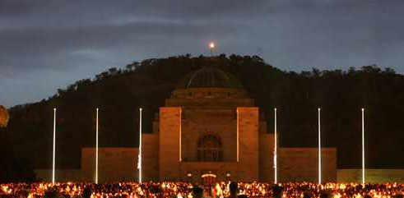

ANZAC Day -Dawn Service
Although ANZAC Day has been around for a long time, its mainstream popularity is a recent phenomenon. Like Australia Day, it is built on the anniversary of a tragedy. On the 25th of April 1915, the British landed Australian soldiers at Gallipoli as part of an offensive against the Turkish control of the Dardanelles. Quite stupidly, they landed the Diggers not on an open plain but on scrub-covered hills. The Turks were dug in from elevated positions and mowed down the Diggers as they leapt from the boats. Of the 1500 men who landed in the first wave, only 755 remained in active service at the end of the day.
The fatuity of the event has led some Australians, such as ex-Prime Minister Paul Keating, to criticise it as being immoral, not in Australia's interests, and a failure. Even if such criticisms were justified, the decision to base Anzac Day on the anniversary of the Gallipoli landing has produced a very unique and a very humane approach to war remembrance. Instead of being a jingoistic celebration like many military days around the world, Anzac Day is very human. It begins solemnly, when descends into a party affair with drinking and gambling.
The key feature of the day is the Dawn Service. During battle, dawn was one of the most favoured times for an attack as the half-light played tricks with soldiers' eyes. Therefore, soldiers were awoken in the dark, so that by the time the first dull grey light crept across the battlefield, they were awake and alert.
The fresh light instilled a sense of optimism for the new day tempered by the fear that it could be their last. For those who survived, it bequeathed memories of burying a mate along with the awareness that they would have to preserve the feelings of what they had lost. When the soldiers returned home, the first light of the morning would once again remind them of their experiences and they sought out the company of those who could understand. On the 25th April 1923 at Albany in Western Australia, the Reverend White led a party of friends in what was the first ever observance of a dawn service. It wasn't until 1927 that the first official service was held at the Sydney Cenotaph. Part of the service includes a paragraph taken from the poem 'Ode for the Fallen'.
"They shall grow not old, as we that are left grow old;
Age shall not weary them, nor the years condemn.
At the going down of the sun and in the morning
We will remember them."
The poem neither attributes right or wrong nor does it glorify war as the liberator of freedom. It simply articulates what the war meant to those who were involved in it. Needless to say, it is a message that prime ministers don't always like. They want soldiers to celebrate dying for the government, not reflecting upon the anguish of war.
For decades, families and young people were not welcome at these dawn services but in recent times, they have been encouraged to take part. They have also been encouraged to take part in marches wearing the war medals of deceased relatives. Arguably this was brought about due to necessity as the stars of the show had a habit of dying each year leading to the very real prospect of crowds one day cheering on an empty street. Another suggested change is to allow the Australians who had relatives that fought on the opposite side, to take part wearing the war medals of the deceased.

Christmas
Although not Australian, religious festivals such as Christmas are well supported. Of course, Santa Claus looks a bit inappropriately dressed in his North Pole attire in the heat of the Australian summer. It's also quite strange listening to people sing about a white Christmas when the temperature is hot enough to fry an egg. Finally, the "traditional" Christmas turkey is also proving to be a little unsuitable for the hot weather. When the temperature is 40 degrees, the last thing people want to do is open the door of an even hotter oven. As a consequence, seafood on ice is gradually becoming Australia's favoured Christmas food.
Sometimes people try to get the northern hemisphere Christmas spirit with lights, charity and carols. Again, the Australian environment is a little problematic. Because it doesn't get dark until 9pm, it can be a bit difficult taking the kids on a tour to see some Christmas lights before bedtime. Furthermore, helping a needy person always feels much better when the needy person is freezing in the snow. It just doesn't provide the same emotional gratification when it is hot, and the needy person looks like a bogan who had been kicked out of pub for having too much to drink.
The hot weather is also having an effect on the design of the Christmas tree. In the northern hemisphere, the Christmas tree is of great importance due to the amount of time a family spends indoors around it. But in Australia, families spend more time outdoors on verandas and barbecue areas where the tree is never seen. Consequently, the tree is often some stringy shrub that has only been included because it's the "traditional" thing to do.
With so much time being spent outdoors, Christmas is strongly associated with sport. A game of backyard cricket may put a gift to quick use, and also smooth tensions between distant family members who, despite thinking they should be together on Christmas, really don't like each other.
For those who find playing sport a bit strenuous, Christmas is followed by Boxing Day where they have a great opportunity to watch it. Boxing Day marks the beginning of the Sydney Hobart Yacht race, and tens of thousands of Sydney-siders will flock to see the Yachts commence their 628 nautical mile journey to the Apple Isle. For the next week, Australians all along the south east seaboard will gaze across the ocean to see the Yachts go by.
While Sydney has its Yacht race, Melbourne has its cricket. Up to 100,000 people will flock to the MCG to see the opening day of the test. Some will be there to get drunk and enjoy the summer sun. Some will be there because they are seriously interested in the cricket. Others will be there because it is Boxing Day tradition.
After Boxing Day comes New Year's Eve. Being in the heat of the Australian summer, this is likely to be spent outside under some fireworks, in a park laying on some grass, on the beach looking at the ocean, or standing on a crowded street looking at an even more crowded nightclub. Couples will enjoy a countdown before heading on their merry way to do what couples do. As for singles, they will await the countdown as an excuse to take the first step towards those things that couples do.
Melbourne cup

Considering that that Australia's top three heroes are a cricketer, a bushranger and a race horse, perhaps it is fitting the only time the nation stops as one is to have a wager on a dubious sporting pastime. The discovery of gold in 1853 led to a huge influx of gamblers to Australia's shores. If the diggers struck it lucky on the goldfields, they would head for the track to see if the luck would continue. Invariably it didn't and racing clubs sought bigger and bigger meetings to relieve the prospectors of their gold.
The Victoria Turf Club staged the first Melbourne Cup in 1861 and by 1866, the Government had proclaimed the day a public holiday. To make life difficult for punters, the race is run over the unusually long distance of 3200m, it may have up to 30 starters and the favoured horses are handicapped with extra weight.
Although knowledge of the form is still a prerequisite to talk like a guru at pre-race functions, the many variables make picking a winner a case of pinning the tail of the donkey. The most successful method seems to be whether it has a good name or not. With the exception of Kiwi which evokes sheep imagery, all winners have had impressive names like Phar Lap, Black Knight or Vintage Crop.
The fact that the cup is such a lottery has helped it gain popularity amongst those with no interest in racing. There is a certain charm associated with seeing a guru who has studied the form all year, grimly stewing as some novice gloats about how she picked the winner only because she thought its name would still be pronounceable after downing her second bottle of Champagne.
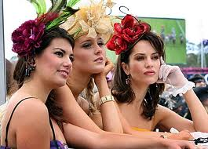
But the Melbourne Cup is more than just a horse race, it is also one of the few times where Australians celebrate looking stylish and acting like a pompous wanker. In a land of the ugg boot and cork hat, world fashion designers rarely seek their inspiration with a trip down under. But on that first Tuesday in November, the dark clouds part and the elegant ladies come out to shine. It is a day when the famous proverb, " the bigger the hat, the smaller the property" is transformed into "the bigger the hat, the smaller the skirt."
Although it is only a public holiday in Victoria, around the country kind bosses stop work and use the day as a team-building exercise. There is usually a sweep, a prize for the best hat and a drink or two or many. Roughly speaking, the popularity of a boss is proportional to the quantity of alcohol drunk and inversely proportional to the amount of work completed on the day.

St Patrick's Day
St Patrick's Day is a popular tradition. Even though it may be in tribute to a patron saint of a foreign country, it involves a lot of drinking hence its appeal. A home grown saint is yet to eventuate. A Ned Kelly Day would be a possibility. As a result of Our Ned's Last Stand, police corruption was cleaned up, and a century of painters, novelists, musicians and poets gained a muse of inspiration. The only problem with a Ned Kelly day would be that having a day to celebrate an executed cop killer would be as ridiculous as having a national day to celebrate criminals.
      - What do Australians celebrate on the 26th of January?
      - What is the usual way of celebrating Australia Day?
      - What is the history of ANZAC Day?
      - What is the key feature of this holiday? Why?
      - What is traditional Australian Christmas food?
      - Do Australians decorate the Christmas tree?
      - What sports are Sydney and Melbourne associated with?
      - When does the most famous horse race in Australia take place?
      - How do some bosses in the country use this day?
      - Why do Australians celebrate Ned Kelly Day?

EATING HABITS

Asian Food. Australian’s Favorites. Bush Tucker.
Modern Cuisine.

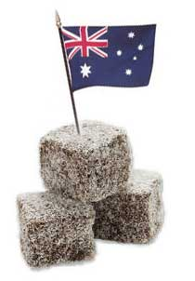
Australian cuisine has the most diverse range, quality, and inventiveness than many others in the world. However, it took Australia some time to evolve from the scenes of meat pies, Vegemite sandwiches, and sausage rolls to the scene of dishes such as "seared kangaroo fillet with wilted beetroot greens and roasted onions". The culinary art of Australia only luxuriated in the 1990s. But at that time, it was already considered the most adventurous in the world. Each capital city has seen a swarm of new restaurants within the genre 'Modern Australia' cuisine, with inventive chefs at the helm and an audience of willing hedonists at the ready. This culinary reawakening is due to two factors: the wealth of superlative Australian produce, including native food, and the plethora of international cuisine brought to Australia by its immigrants from all over the world.
Australia is also well known for its fresh ingredients such as seafood, local fruits, beef and lamb, as well as its world class cheeses. Like in Italy and France, Australia can be divided into regions that are known for particular produce such as King Island cream, Sydney rock oysters, Bowen mangoes, Coffin Bay scallops, Tasmanian salmon, and Illabo milk-fed lamb. Each state has its acknowledged specialties, which travelers should take advantage of.
Never forgetting the native cuisine called 'bush tucker', which involves traditional diets such as flour and water cooked in the campfire coals to make bread called damper, billy tea, and local animals' meat. To summarize the varieties of food in Australia, it is then necessary to categorize them into modern Australian food, bush tucker, Asian food, and Australian's favorite.
The food culture brought to Australia by English immigrants who first settled in South Australia in 1836. These people brought with them traditional English recipes. They were all simple recipes, not requiring complicated ingredients, and not costing much money, a style of cookery that reflected the modest means of the time.
Among the English immigrants were sheep graziers providing prime lamb, others farmed beef cattle and still others became the butchers, bakers and candlestick makers of newly established towns. Many recipes, in hand written recipe books, brought to Australia by migrant women have been passed from one cook to another down the years. These recipes still hold their place in home cooking of today including Lamb Roast, Lamingtons, tasty Steak and Kidney Pies. They have been joined by dishes that have earned their special place in Australian history, such as the Pavlova, Soldier's Cake and Anzac Biscuits, and of course for genteel afternoon teas, the Lamington and Pumpkin Scones. Damper: A damper is a traditional Australian bread, made without yeast, and commonly made on a campfire in a cast iron camp oven.
Lamingtons: A chocolate coated cube of sponge cake, rolled in
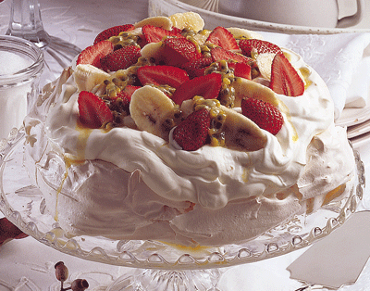
desiccated coconut; usually served with whipped cream and afternoon tea. It is said that Lamingtons were invented in the Queensland Government House kitchen as a creative use for stale sponge cake. I do not recommend that you use stale cake, but the mixture is easier to handle if the cake is not too fresh and crumbly. They are named after Lady Lamington, the wife of the Governor of Queensland from 1896 to 1901.
Pavlova: A recipe developed by a chef in Western Australia, or so the story goes (or was it in New Zealand?) to celebrate the visit of the famous ballerina Anna Pavlova, is a confection of sugar and egg white meringue, covered with delicious whipped cream and seasonal fruits.
Anzac Biscuits: A rather hard but crisp biscuit of rolled oats and molasses Soldier's Cake.
Although English immigrants brought their foods and recipes to a new land, there was already a wealth of cultural food in existence. These are the indigenous foods and style of eating that of course was the very
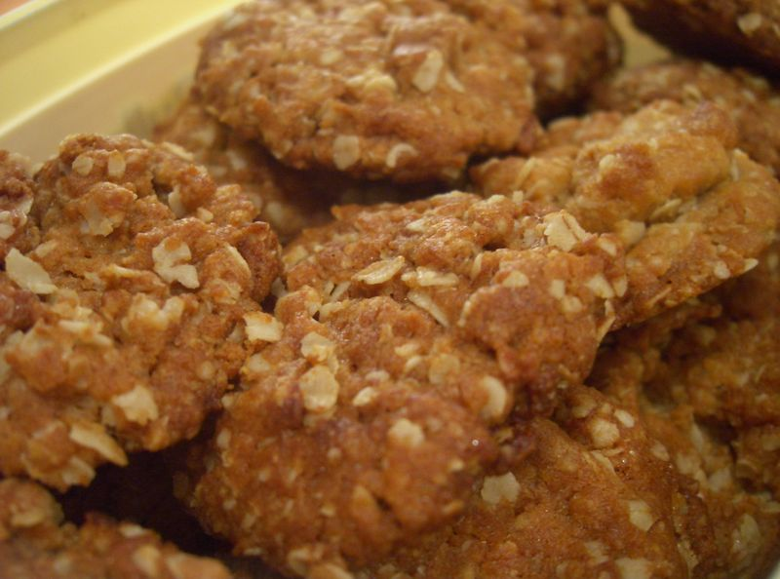
first cuisine established in this country. It may have taken many decades for this to be acknowledged, but there is an awakening taking place both in Australia and internationally.
The oldest food culture is indigenous Australian food or native food.
For centuries the indigenous people of this country have used the fruits and plants growing widely on the land. It may have taken a long time, but it is satisfying to realise that Indigenous foods are becoming more widely known and available, being grown very successfully by a group of visionary farmers in South Australia, and enabling the creation of dishes such as: Calamari seasoned with lemon myrtle, Lemon myrtle linguine tossed with local scallops and prawns, Native spinach fettuccine with Springs Smoked Salmon with creamy bush tomato and macadamia sauce, Kangaroo fillet crusted with Mountain Pepper, and served with a pepper berry dressing and fresh leaf salad. Damper is a perfect example of a food passed from one tradition to another. The aboriginal people have traditionally ground seeds to make a kind of flour, added water and baked a kind of Damper in the coals of their cooking fires. Damper became the means of outback stockmen having fresh bread, but using the more traditional flours, and using a camp oven for baking in the hot coals of the camp fire. In Oz we have a little freshwater crustacean that lurks on the bottom of streams, lakes and in farm dams, they are called Yabbies, and have been enjoyed by indigenous Australians for centuries.
An enterprising lady at Inman Valley, looking to diversify on a dairy farm during a downturn in the dairy industry, tried farming yabbies in her farm dams. She has established a successful and innovative business,
buying and marketing yabbies. Now the rest of the world is waking up to their secret delights. Their delicate, sweet flavour and firm texture has won lavish praise from connoisseurs the world over. They are absolutely
delicious, and can be used in Yabbie Chowder, Yabbie Pate, or Yabbie Stir Fry with Asian vegetables.
Lemon myrtle: fresh leaf, or ground dried leaf of the Lemon Myrtle tree.
Mountain Pepper: ground leaf or berries of the mountain pepper tree
Native spinach: warrugul greens, a native spinach growing in coastal areas
Bush tomatoes: small tomato-like fruits, also called desert raising
Macadamia nuts: a nut, native of Australia, now grown in other places
Wattle seed: A small, oval, black variety of the Acacia seed. Wattle seed is used in myriad foods including rice, soups, meat rubs and baked goods.
Although English immigrants brought their foods and recipes to a new land, there was already a wealth of cultural food in existence. These are the indigenous foods and style of eating that of course was the very
first cuisine established in this country. It may have taken many decades for this to be acknowledged, but there is an awakening taking place both in Australia and internationally.

          - Does Australia have long culinary traditions?
          - What types of food is Australia traditionally famous for?
          - What are the main dishes of so called “bush tucker”?
          - Who brought culinary traditions to Australia?
          - Can you name any traditional Australian dishes? What kind of dishes are these?

SO, WHAT ARE AUSTRALIANS LIKE?
Australians have typically been described as laconic, egalitarian, rugged, no-nonsense, down-to-earth types obsessed with sport but uneducated in the more refined arts of civilization. There may be truth to the cliche, but as with any cliche, it can only describe one layer of the truth. And the whole idea is to show that there are many layers to reality, each piled on top of another onion-style. In order to understand the Australians, you have to understand where they come from. There have been four principal migrations of humans into Australia. The first three were Aboriginal waves, and the fourth, which continues today, began with the European colonization of 1788. It is important to note that, unlike the colonists who flocked to America, the early immigrants to Australia didn't go by choice, in a vast number of cases. Early Australia was a prison for the trash of the British Empire – or at least a dumping ground for dangerous elements of British society. White Australia began as a convict nation -- a land settled by criminals. There was never a sense that this was a Promised Land, to be developed and built into a new Paradise on Earth, as was the case with America. Rather, Australia was a place to be hated and despised by the people who were sent there. It is mentioned that the "typical Australian ethos was developed by the convict, working-class, Irish and native born peoples".

1. How have Australians typically been described?
2. How many principal migration to Australia have there been? What
were they?
3. How did White Australia begin?

FAMOUS AUSTRALIANS

There are many famous Australians who have helped to shape Australia as a nation. Australia is largely multi-cultural and as such our famous australians can vary between our cultural sub category. There are however a few names that rise above the pack and truly reflect Australia as a country. These people have helped to inspire Australians and make the country that Australia is today.

Steve Irwin

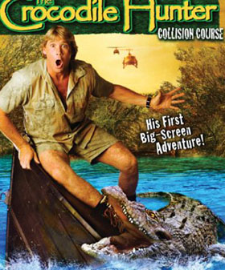

The Australian larrikin, ecologist and television celebrity, Steve Irwin was a larger than life personality. His mission was to protect and save animals, especially the endangered species. He was committed to educate the public about wildlife and about the conservation of the natural world.
His interest in animals came from his parents who were running a small reptile park in Queensland. He learned to feed, love, handle and also defend himself against dangerous animals at a very young age.
Later on when he took over the management of the family business he turned it to one of the major tourist attractions in Australia. And Steve Irwin’s natural abilities as a showman made Australia Zoo famous internationally.
Together with Terri, his wife, Steve presented the "Crocodile Hunter" television documentary about dangerous reptiles. The show started in Australia in 1996, then captured audiences in the US and UK.
Building on this work, Steve Irwin continued with a new show about the "Ten Deadliest Snakes in the World".
He became a legend around the world for his stunts, passion, enthusiasm and agility to handle the lethal animals and to demonstrate to the public the importance of preserving their habitats.
As an advocate of wildlife protection, he endorsed Australia’s stringent customs requirements in media campaigns. His message focused on quarantine being essential to support the country’s unique environment.
Steve Irwin died in 2004, pierced in the heart by a stingray, while snorkelling at the Great Barrier Reef.
Terri continues his work at the Australia Zoo together with their daughter Bindi, who hosted her own television show when she was only 9, in 2007.
Passion for wildlife just runs in the family.

            - Why do many people all over the world know Steve Irwin?
            - Did Steve love animals when hi was a child?
            - What made Australian Zoo famous internationally?
            - What did he do to support the country’s unique environment?
            - Who continues his work?

Ned Kelly - Such Is life

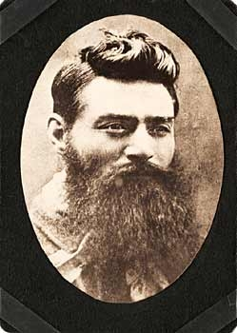
Ned Kelly (1854-1880) was an Australian bushranger, who was considered a folk hero among many for his defiance of the colonial authorities at the time. Ned Kelly was born in Victoria to an Irish convict father (convicts were a major proportion of Australia at this time). After an incident at his home in 1878, Ned Kelly's mother and friends were convicted and taken away. Ned Kelly fled and ended up murdering three policemen (in self defence), from that day Ned Kelly and his gang became wanted outlaws.
Soon the entire Victorian and New South Wales police force began hunting down Ned Kelly. He not only evaded capture, but he started to fight back; robbing banks and distributing the money to his supporters for legal fees.
Ned Kelly made his final stand in a violent confrontation with police at Glenrowan, using home made steel plate armor. He suffered 28 bullet wounds before being caputred and sent to jail. He was hanged for murder of the three policeman at the Old Melbourne Gaol in 1880. Ned Kelly's final words were "Such is life"

- What is Ned Kelly famous for?
- How did he become a criminal?
- What were his last words?

Burke and Wills - The Great Explorers

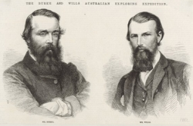
In 1860 Robert Burke and John Wills led an expedition of 18 men, the goal was to cross Australia from Melbourne to the Gulf of Carpentaria. A distance of about 2800km. At the time of their expedition most of inland Australia had yet to be explored and was unknown to settlers.
The south-north leg was completed successfully, but on the return journy both Burke, Wills and nearly all the men died. Leaving John King to be the only person to travel the entire expeidition and return alive to Melbourne.

  - What was the goal of Burke and Wills expedition?
  - How did the expedition finish?

Phar Lap - The Loser Horse That Became A Champion

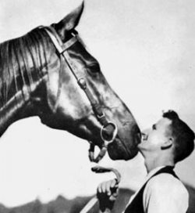
Australian's love the underdog (or underhorse), its part of the culture and Phar Lap was definetely an underdog after not placing in his first 8 races. Yes, Phar Lap is a racing horse, but this horse did more then what any human could and united Australia during the great depression.
Phar Lap was born of poor bloodline and was covered in warts, he even nearly died when someone tried to shoot at him. But Phar Lap had heart, actually a heart twice the size of any horse.
Phar Lap went on to win 37 out of his 51 starts, a tremendious winning ratio. He left for America and won his first race with ease, however Phar Lap died the next day.

    - Who is Phar Lap?
    - How many starts did Phar Lap win?

Banjo Patterson - The Bush Poet

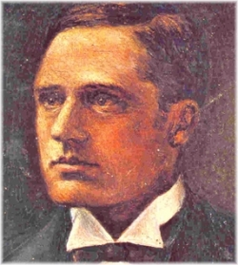
Banjo Patterson (1864-1941) was a famous Australian poet, author and journalist. He wrote poems about Australian life with particular focus on the bush, rural and outback areas of Australia. His most famous poems include "Waltzing Matilda" and "The Man from Snowy River".
Banjo Patterson is still one of the most wildly known and respected Australian writers. He appears on the Australian $10 note.
      - What did Banjo Patterson write about?
      - Where can you see the portrait of this famous poet?

Ian Thorpe

Ian Thorpe’s achievements in the water are nothing short of phenomenal. He is one of the country’s most prolific sportsmen, but it is the way he has managed his success and his genuine humility and commitment to helping others that most people find incredible and has earned him respect and admiration internationally. It is difficult to fathom how a 27 year old has achieved so much and he still has so much ahead of him following his recent withdrawal from competitive swimming.
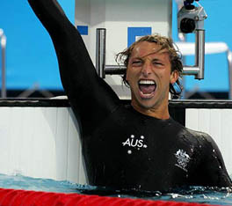
Ian has broken 22 world records, has won three gold and two silver medals at his first Olympic Games and two gold, one silver and one bronze at the 2004 Athens Olympics and in doing so has become Australia’s greatest ever Olympian. He has won 11 World Championship titles (the most ever), ten Commonwealth Games gold medals and nine Pan Pacific titles. He is currently the world record holder for the 400m freestyle event (plus holds the short course world records in the 200m and 4 x 200m freestyle events). Ian also broke the Commonwealth record in the 200m individual medley event at the 2003 Australian Championships and again at the 2003 World Championship in Barcelona.
Ian’s professional approach to swimming, his ability to deliver under pressure and his humble attitude and integrity have earned him praise from his peers, the public and world leaders. In Japan 2001, Ian won the most gold medals ever at a single World Championships. Four out of the six gold medals were in world record times and he is the only swimmer in history to successfully defend a 400m freestyle world & Olympic title. Ian’s unbelievable achievements have also given him international celebrity status.
Ian has also hosted and appeared on an abundance of non-sport related TV shows. He has been the promotional face of international events and the recipient of dozens of outstanding awards in Australia, France, China, USA and Japan. The IAAF awarded him the 2001 American International Athlete Trophy as “The World’s Most Outstanding Athlete”, in 2002 he was voted by the Foreign Press as the best representative of Australian culture, attitude and ideals, and was awarded the “2002 Australian Face Abroad Award”. Ian received the 2003 Outstanding Male Athlete for the 24th Commonwealth Sports Awards, Sydney’s Greatest Ever Male Sports Star – as voted by readers of The Daily Telegraph and also the 2003 Telstra Australian Swimmer of the Year for the fifth consecutive year.
The Australian Championships have also been exceptionally successful for Ian. He won his first national 100m title in 2001 and became the first man since John Konrads, 40 years ago, to win every freestyle event from 100m to 800m at a national championship. Altogether Ian has won an astonishing 21 national titles.
From a young age, Ian has been renowned for being highly articulate, generous and empathetic. In 1999, Ian made history when he broke four world records in four days at the Pan Pacific Championships in Sydney. He won $25,000 and donated it to Lifeline and the Children’s Cancer Institute of Australia. In the belief that all children should have a fair go, Ian created and launched Ian Thorpe’s Fountain for youth in 2000 which has allowed him to support children in need, improving health and education outcomes for children, especially Indigenous children in Australia.

        - What made Ian Thorpe internationally famous besides his swimming victories?
        - What are Ian’s sport achievements?
        - How did he spend the money he wan at the Pan Pacific Championships in Sydney?

Fun Facts About Australia
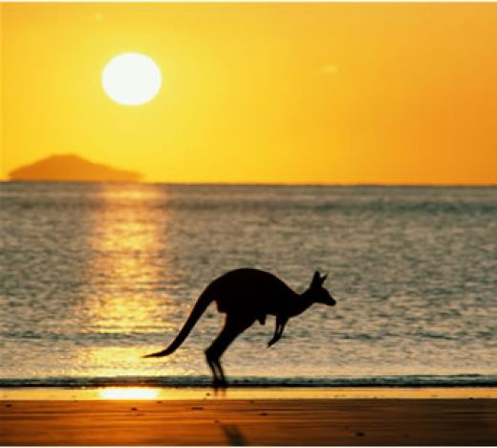

In this article we will learn some fun facts about Australia, "The Land DownUnder". Australia is the world’s smallest continent but is also the sixth largest country in the world! If it is summer here then it's winter there! Australia has some incredibly hot weather and some of the world’s greatest animals and forests. The hottest temperature actually reached 53.1C in 1889. If you want to go to Australia you should learn some of their unusual lingo. Yes, they do speak English but they have their own language for almost everything. Australia is referred to as "The Island Continent". Here are some unusual terms and their meanings:
- -barbie-barbecue grill
- -clobber-clothes
- -cozzie-swimsuit
- -fairy floss-cotton candy
- -Give it a burl!-means give it a try!
- -mozzie-mosquito
- -ripper-terrific
Fun Facts
- -the national anthem is referred to as "Advance Australia Fair"
- -1/5 of the land is desert
- -Australia was once a British penal colony was thieves, murders etc
- -european settlers drank more alcohol per person then any community in history
- -basic currency are huge cans of beer
- -pubs occupy more land than the mines
- -Australians love meat pies
- -the zoo has no cages!
- -the koala, emu, kookaburra and kangaroo originated in Australia
- -more venomous snakes than any other continent
Here are some fun facts on geography:
- -no part of Australia is more then 1000km from the ocean
- -Australia has the worlds largest cattle station
- -90% of Australians prefer the coastal cities
- -Australians from Queensland are called "banana benders"
- -people from Western Australia are called "sandgropers"
- -Tasmania has the cleanest air in the world!
- -there is a mailbox located on the Great Barrier Reef
- -the Australian Alps get more snow then Switzerland!
- -Melbourne has the second largest Greek population
- -Australia is the lowest and flattest continent
Some fun facts on animals:
- -Australia has the worlds biggest population of one humped camels
- -Australian Dragonfly is clocked at 55 miles an hr!
- -sharks are immune to all known diseases
- -the kangaroo "the burrowing boodie" lives underground

Some more facts
- Did you think the Tasmanian Devil was just a cartoon character you could watch on Saturday mornings? Well it turns out there really is a Tasmanian Devil. Not only that but it has the jaw strength of a crocodile!
- There was a skeleton found in South Wales, Australia. It was female and thought to be 38,000 yrs old! That is incredible!
- There are no truly inland Australian cities. They're all more or less on the coast. Most of the inner areas are considered difficult to live in if not uninhabitable.
- Australia was home to thousands of prisoners.
- There were originally over 200 languages in Australia.
- Australia was first inhabited over 40,000 years ago by Aboriginal people. These tribes of Aborigines in the states and across the country spoke over 200 languages and dialects. However, more than half of these dialects are now extinct, as over ninety percent of the original Aborigines were killed when the British settled the continent, mostly as a result of diseases the Europeans brought over.
- Australia is the smallest continent in the world.
- Australia can claim itself as a country, continent, and island. While it is the smallest continent in the world, it is also the largest island in the world. In addition, Australia is the only country in the world that makes up an entire continent. The majority of the people in Australia live in the large coastal cities because over ninety percent of Australia is actually dry and flat, and about three quarters of the land can't support any type of agriculture.
- The population of Australia is more sheep than people; in fact, there are roughly ten sheep in Australia for every person. As a result, Australia is the largest exporter in the world of lamb meat and wool.
- Australia's most famous animals are unique to Australia only.
- Australia is a smart country. Presently, Australia claims to have a 100% literacy rate, one of the highest in the world. Perhaps this is why they read more newspapers per capita than any country in the world.
- Australians love to gamble. Per capita, Australians spend more money on gambling than any other country in the world. And although they make up less than one percent of the total population of the world, Australia has over twenty percent of the world's poker machines.
As you can see from these few facts, Australia is a country that is full of interesting facts, both from the past as well as the present.

Методическое издание

Автоpы-составители:
Катаева Екатерина Георгиевна
Полякова Наталья Евгеньевна

Английский язык
AUSTRALIA
Методический материал для формирования лингвострановедческой компетенции студентов неязыковых факультетов

Издается в авторской редакции

Подписано в печать 07.06.2010.Формат 60х84/16.
Усл.печ.л. 4,88. Уч.-изд. л. 4,2

Редакционно-издательский отдел
Пермского государственного университета
614990. Пермь, ул. Букирева, 15

